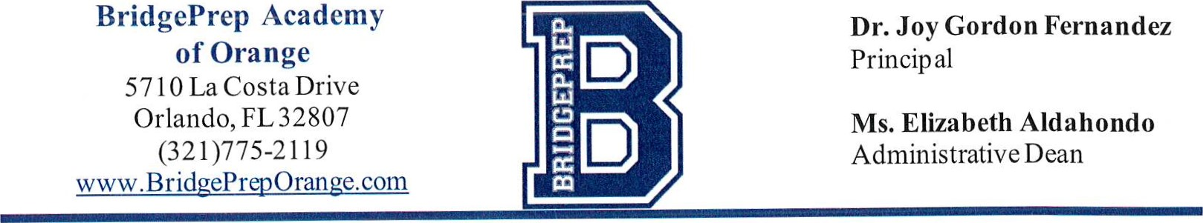

January

4,

2021

Dear Parents and Guardians

Each year we strive to provide the best academic and social experience for our students. It has been our privilege to have had your children at BridgePrep Academy of Orange for this past school year.

In order to better plan and budget for the upcoming 2021-2022 school year, we need to know your intentions for next school year. Please visit our website at http://www.bridgepreporange.com and locate the red button labeled Current Student Intent Form on the left hand side of the homepage. Below is the image of the link on the website as



well

as

the

direct

link

to

the

form.

The Current Student Intent Form must be completed and submitted electronically by Friday February 12, 2021 via webpage link.

If your intent is not received by the above date, it will be assumed your child(ren) will not be returning to BridgePrep Academy and as such your child will lose their spot in our school and replaced with an incoming applicant.

If you have any questions or would like further information, please contact our school office and request to speak to Ms. Felicia Hopkins (321)775-2119.

Respectfully yours,

Joy Gordon Fernandez

Principal